EXPERIMENT- 22
Perform Sharpening of Image using Laplacian Mask with Positive Center Coefficient
Aim
To write a Python code to sharpen an image using Laplacian mask with positive center coefficient in OpenCV for improving image clarity and edge sharpness.
Code
import cv2
import numpy as np
from google.colab.patches import cv2_imshow
from google.colab import files
uploaded=files.upload()
image_path=list(uploaded.keys())[0]
image=cv2.imread(image_path)
if image is None:
print("Error: Image not found")
else:
kernel=np.array([[0,-1,0],[-1,5,-1],[0,-1,0]],dtype=np.float32)
sharpened_image=cv2.filter2D(image,-1,kernel)
print("Original Image")
cv2_imshow(image)
print("Sharpened Image")
cv2_imshow(sharpened_image)

Output Image
Sharpened Image
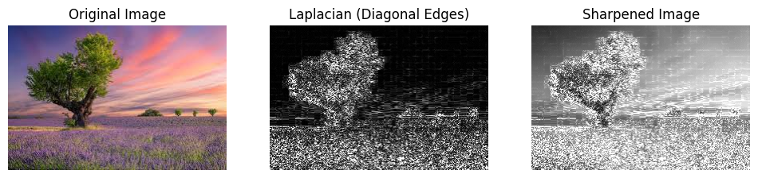
Result
Thus, the image was successfully sharpened using Laplacian mask with positive center coefficient in OpenCV.

